# CS 255 System Design Document

*Sarah Dowd*

## UML Diagrams

### UML Use Case Diagram

### UML Activity Diagrams

*Following are activity diagrams for booking a driving lesson, and taking a practice test, respectively.*

### UML Sequence Diagram

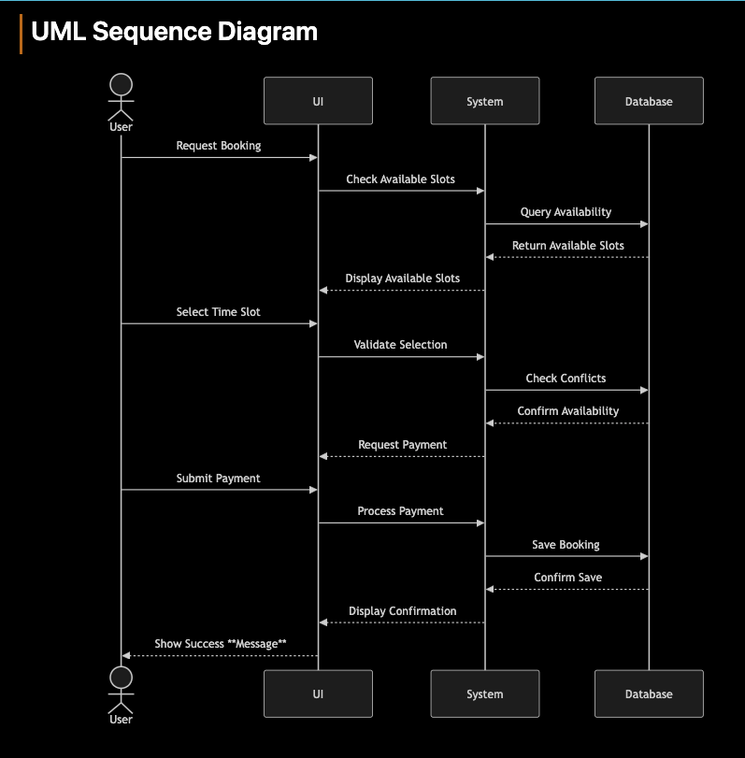

### UML Class Diagram

## Technical Requirements

Hardware Requirements

* Web servers capable of handling concurrent user connections
* Database servers for storing user data, bookings, and test results
* Backup servers for data redundancy
* Load balancers for traffic distribution
* Client devices (computers/mobile devices) with modern web browsers

Software Requiremnts

* Cloud hosting platform (AWS/Azure/GCloud)
* Web server software (e.g., Nginx, Apache)
* Database management system (e.g., PostgreSQL, MySQL)
* SSL certificates for secure connections
* Modern web browsers (Chrome, Firefox, Safari, Edge)
* Payment processing integration
* DMV integration API

Network Requirements

* High-speed internet connectivity
* Secure VPN for administrative access
* Firewall protection
* Load balancing configuration
* Regular backup network connectivity

Security Requirements

* SSL/TLS encryption for all data transmission
* Multi-factor authentication for administrative access
* Regular security audits and penetration testing
* Automated backup systems
* Role-based access control
* PCI compliance for payment processing

Development Tools

* Version control system (e.g., Git)
* Continuous Integration/Deployment pipeline
* Testing frameworks
* Development, staging, and production environments
* Monitoring and logging tools

Infrastructure

* Cloud-based infrastructure for scalability
* Content Delivery Network (CDN) for better performance
* Database replication for data redundancy
* Automated scaling based on traffic
* Disaster recovery system